**Astronauts active on ISS Repeater**

Terry Osborne ZL2BAC [zl2bac@amsat.org](mailto:zl2bac@amsat.org)

As a follow up to my previous article [1], there has recently been a lot of activity from astronauts John Shoffner, KO4MJC and Woody Hoburg, KB3HTZ, (aka @Astro_Woody) operating as NA1SS on the ISS Cross band repeater. The contacts are typically over USA and Europe. See AMSAT ANS news bulletin [2]. It would be interesting to find out if any ZLs have made a contact. To check the activity, see the AMSAT Status page [3]. Some people report “Crew Active” when the astronauts are making contacts. See Figure 1.

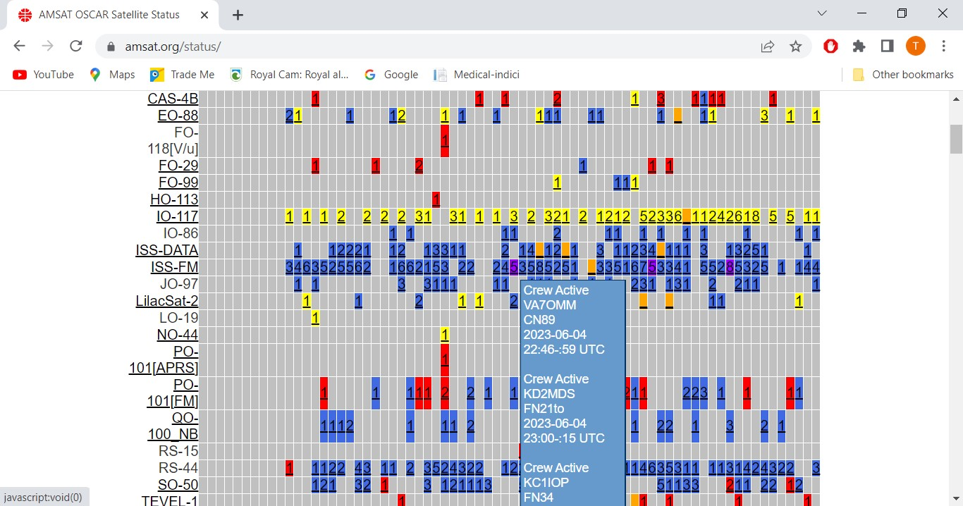

**Figure 1.**

Tracking: A good source of tracking apps is here [4] although the easiest “On Line” app is the “amsat pass prediction” page [5]. See Figure 2. It is a bit “clunky” on a phone but works fine.

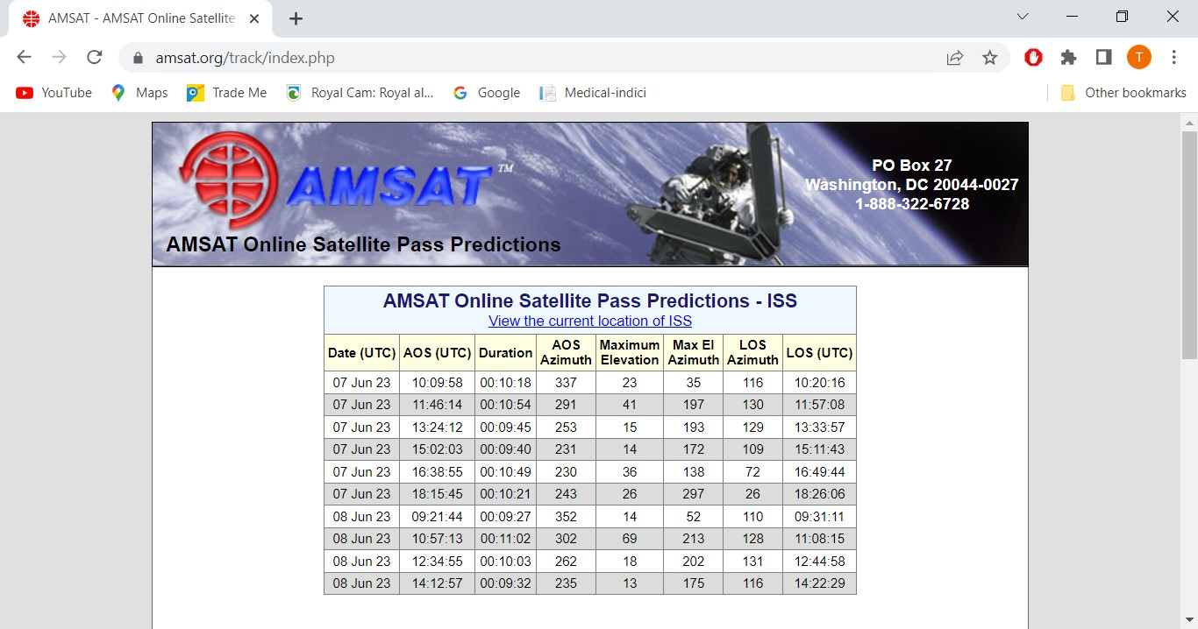

**Figure 2.**

In the previous article, I mentioned that a better antenna and a proper Dual Band Mobile would give much better results. This youtube video [6] shows what can be achieved and how good the signals from NA1SS can be. Patrick WD9EWK is using an ICOM IC-5100 and an ELK log periodic beam antenna. For another youtube video from NA1SS see [7].

**Quote:** “If any crewmember is so inclined, all they have to do is pick up the microphone, raise the volume up, and talk on the crossband repeater. So give a listen, you just never know.”

**Reminder of the Frequencies:**

Downlink (receive) 437.800 +/- Doppler of 10 KHz. Uplink (transmit): 145.990, with 67 Hz CTCSS tone and no Doppler correction required.

**References:**

[1] Break In January/February 2023 page 12 “ Working the ISS Repeater with a Baofeng UV5R”

[2] <https://www.amsat.org/ans-155-amsat-news-service-weekly-bulletins/>

[3] <https://www.amsat.org/status/>

[4] <http://sats.wikidot.com/what-apps-can-i-use-to-track-satellites>

[5] <https://www.amsat.org/track/index.php>

[6] <https://youtu.be/2nbH5MVy9Pw>

[7] <https://youtu.be/G39_Taa0RoE>